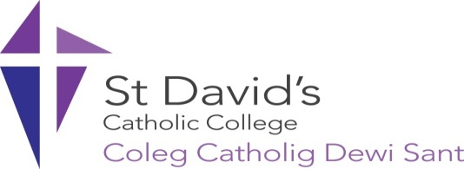 SCHOLARSHIP APPLICATION FORM FOR 2024/2025
A Catholic college for the community, seeking to discover and realise the full potential of all in an atmosphere of love, service and respect inspired by Christ.
At St David’s College, we believe that education is about transforming lives and allowing learners to reach their full potential, and we are committed to attracting the most talented and dedicated learners, regardless of their geographic, social or financial background.
Guidelines
- We are offering two types of scholarship for 2024/2025; one for academic achievement and one for contribution to the community. You can only apply for one scholarship. Applications for the academic achievement scholarship and the contribution to community scholarship should be made using the same application form.

- You will need to send photographs/ copies of your qualifications/ exam results slips with your application form as proof of your qualifications.

- You will need to provide supporting documentation with your application, for example, certificates of attendance and other certificates you may have gained during your time at school.

- Please ensure that your application is clear and legible. Only applications made electronically will be accepted.

- The deadline for applications is Tuesday 27th August 2024 (11.59pm). Candidates may be invited for interview as part of the selection process.

For 2024/2025, each scholarship will be worth £1250 each year. The contribution to community will be £1000 for student and £250 to their nominated charity.

Please submit your completed application to the address below:
Mrs L Newman, Deputy Principal
Email: lnewman@stdavidscollege.ac.uk
Successful candidates, who are awarded a scholarship, will be asked to contribute to promotional activities.
Personal details

Title (Mr/ Miss/ Ms)
Family Name
First Name
Date of Birth
Address
Postcode

Telephone

Email

Nationality

Scholarship Applied for
(Academic Achievement Scholarship or Contribution to Community Scholarship)

Application details

Current Qualifications (An example has been provided)

School | Subjects | Qualifications (e.g. GCSE, BTEC Level 2) | Grade Awarded | Date Awarded
Corpus Christi | English Literature | GCSE | B | August 2014

Provide a personal statement to support your application for a scholarship (in approximately 500 words). You can make reference to:

- Your existing academic achievements and where you have achieved a high standard in your studies
- The skills and specialist knowledge that you have gained
- The courses that you hope to study whilst at St. David’s and your future career aspirations
- Outstanding achievements in the face of adversity and personal achievements
- What motivates you
- School and community involvement to date
- Future plans to contribute to college life and wider community involvement

I confirm that the above information is true and that if I have made a false declaration I may be liable to legal action by Saint David’s Catholic Sixth Form College.

Student signature: Date:

